# Homework 1 (85 points)

This homework will cover Chapter 2 in Python Crash Course and Chapter 1 in Automate the Boring Stuff textbooks. Read these chapters for more information and review the lecture slides posted on Moodle.

Respond to Questions 1-8 in this Word document, using a red font color for all of your responses. For Questions 9 and 10, write two separate Python scripts. Upload a zip folder containing a Word document with your responses and both Python scripts to receive full credit.

NOTE: CODE THAT DOES NOT COMPILE WILL BE GIVEN 0 POINTS. If you cannot get part of the assignment working, just send the part that compiles correctly.

## Question 1 (2 points)

Write a line of Python code that will print out the name of your favorite movie or TV show.

print(“out the name of your favorite movie or TV show.”)

## Question 2 (5 points)

What will the following lines of Python code print to the screen?

x, y, z = 23, 49, 3

print(x+z)26

print(x/z)7.6666

print(x**z)12167

print(y//z)16

print(y%z)1

## Question 3 (8 points)

What will be printed to the screen? How can you fix the script to not overwrite the message value?

message = “Did you ever hear the tragedy of Darth Plagueis The Wise?”

print(message)

message_2 = “I thought not. It’s not a story the Jedi would tell you.”

print(message_2)

## Question 4 (6 points)

Which of the following are valid variable names in Python? (type valid/invalid after each item)

1. message_1 valid
2. student id invalid
3. GRIZZZ/ID invalid
4. account# invalid
5. b&b_name invalid
6. MAX_STUDENTS valid

## Question 5 (10 points)

For the following questions, (1) find and explain the error(s), and (2) fix the error(s). You must include both parts to receive full credit.

1. print(“Hello there.”) missing parentheses
2. response = ‘General Kenobi!’

print(response) spelt response wrong in print statement

1. laugh = “HA” * 5~~.0~~ can’t multiply string by float
2. movie = “Toy Story” + “3” missing quotes around 3
3. cost = float(input()) cant add float and string

total = 100.00 + cost

## Question 6 (2 points)

How would you fix the error in this screenshot?

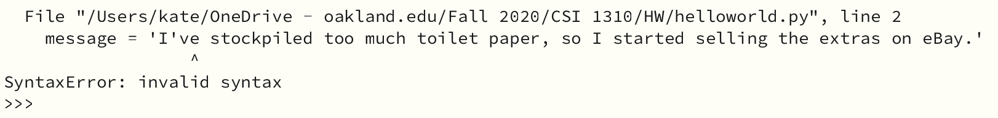use double quotes at the beginning and end of the string instead of single quotes

## Question 7 (6 points)

List three examples of whitespace and write three lines of Python code that prints each to the screen.

Tab, new line, and empty string

Print(\t)

Print(\n)

Message = ” “

Print (Message)

## Question 8 (4 points)

Write a line of Python code that concatenates two strings and prints the result to the screen. Use any string that you like, +1 point if you can somehow tie it into a meme. Write a second line of Python code that uses string replication.

Print(“there is” + “no meme”)

Laugh = “HA” * 5

## Question 9 (12 points)

Go to <https://www.asciiart.eu> and find an ASCII art design that you like. Write a Python script that prints the design to your screen. Pay attention to the use of double/single quotes and ensure that all characters are properly printed to the screen.

## Question 10 (30 points)

Write a Python script that, in this specific order:

1. Greets the user
2. Asks the user to enter a name
3. Saves the input name as a variable
4. Removes whitespace to the left and right of the name, and saves it to a variable
5. Prints the stripped name with first letters capitalized (title case)
6. Prints the stripped name with all letters capitalized
7. Prints the stripped name with all letters uncapitalized
8. Prints the name as the user entered it

Make sure that your code is commented or you will lose points.